Automation of Daily Rates Checking
As-Is Documentation

Prepared by: Pei H Trojani Chan
CTAC-LA1
13 February 2025

Background
To ensure the accuracy of accounting and loan servicing for the non-USD denominated ADB’s sovereign loan portfolio, CTAC-LA1 regularly checks the foreign exchange rates and interest rate index applicable to these currencies. Checks are necessary for the following:

FX Rate | Interest Rate Index
1) Billing statements’ print/cut-off dates | 2 or 1 day/s before the 1st and 15th day of the month, depending on the applicable day-lag per currency
2) Capitalization dates
2) Every month-end
3) For dates with reported errors in FX

This control is essential because exchange rates and interest rate indices directly affect interest calculations and billing.

Detailed Steps and Screenshots

Checking of Interest Rate Index

- Access the interface files from the designated folder.
\\wpclass01\acbs-int\acbsprd\REUTERS_IXRATE\DAILY_DATA
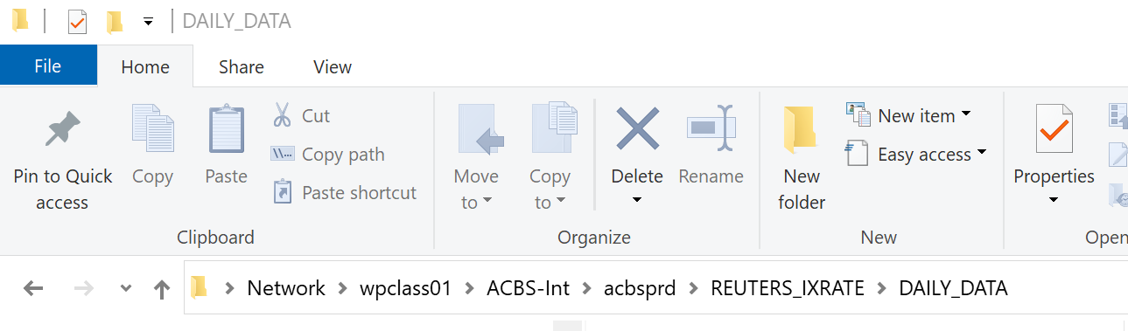

- Select the interface file date that corresponds to the currency being checked.
Please note of the lag days applicable to each currency:

Currency | Lag Days
CNY | 1 day (Example: To check to index rate applicable to 15Jan2026, select the 14Jan2026 index file)
EUR | 2 days (Example: To check to index rate applicable to 15Jan2026, select the 13Jan2026 index file)
NZD | No lag day
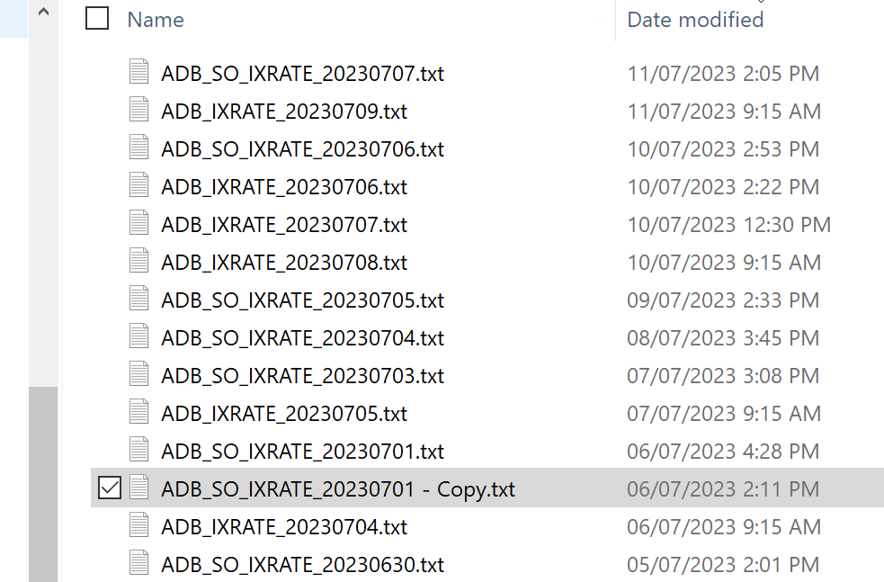

- Access the published index rates.
Currency | Official Website
CNY | https://www.shibor.org/shibor/dataservicesen/
EUR | http://www.euribor-rates.eu/current-euribor-rates.asp
NZD | http://www.nzfma.org/data/search.aspx

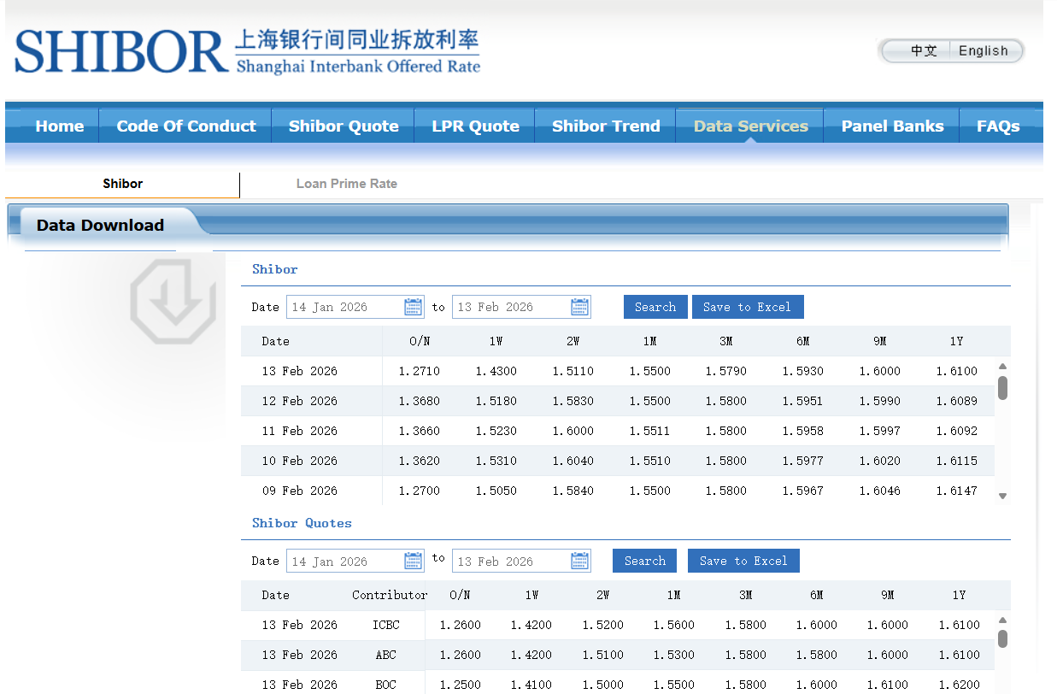
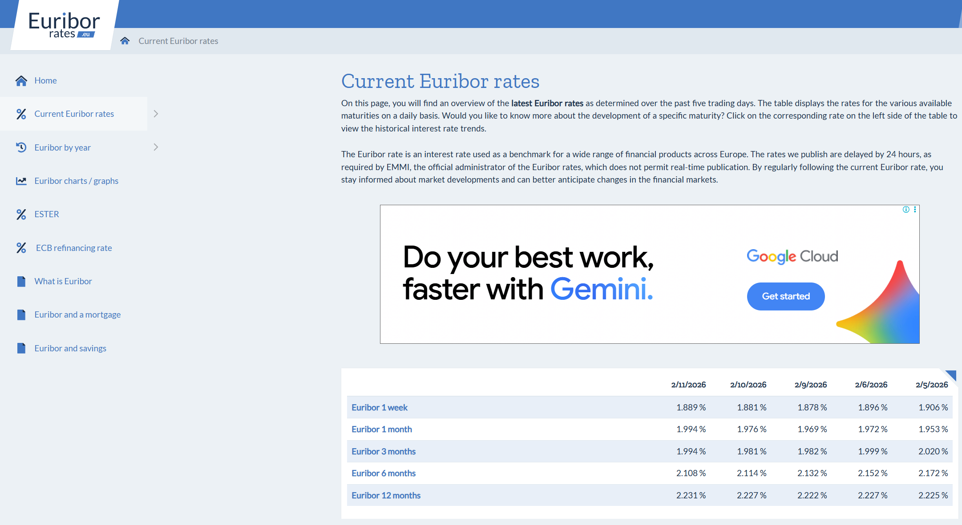

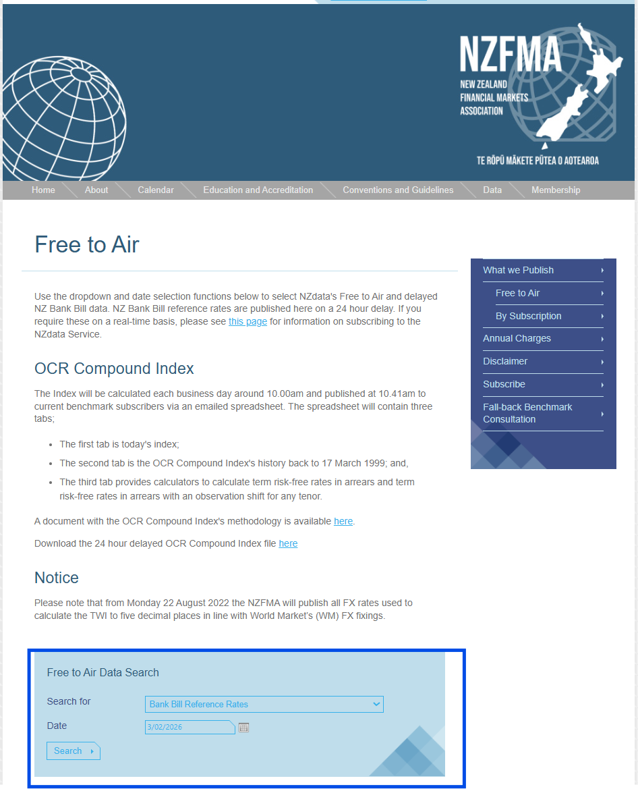
- Compare the index rates per the interface file versus the published rates.
Interface File Published Rates
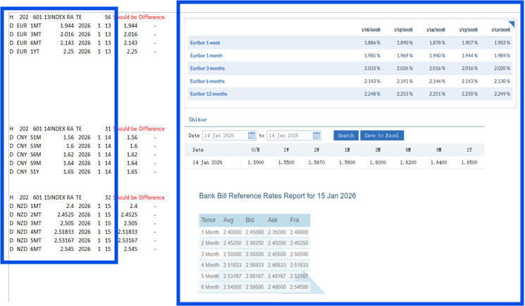

- For any discrepancies noted, e-mail ITD for the required updates in the index rates.

Checking of Foreign Exchange Rates

- Access the interface files from the designated folder.
\\wpclass01\ACBS-Int\acbsprd\INFXRATE_Staging

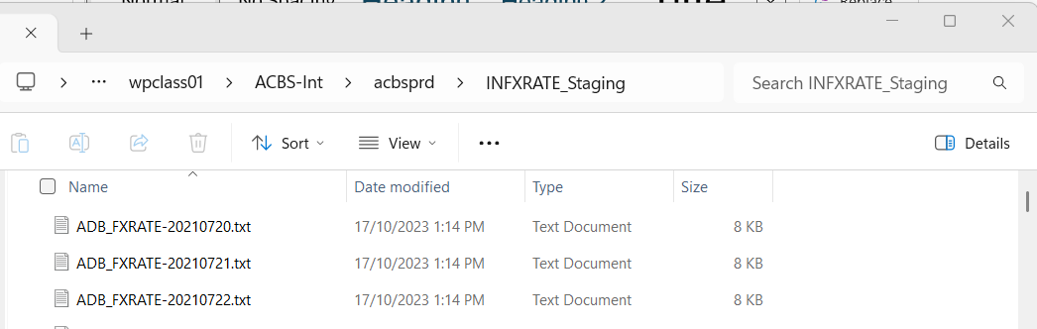
- Download the foreign exchange rates from Oracle
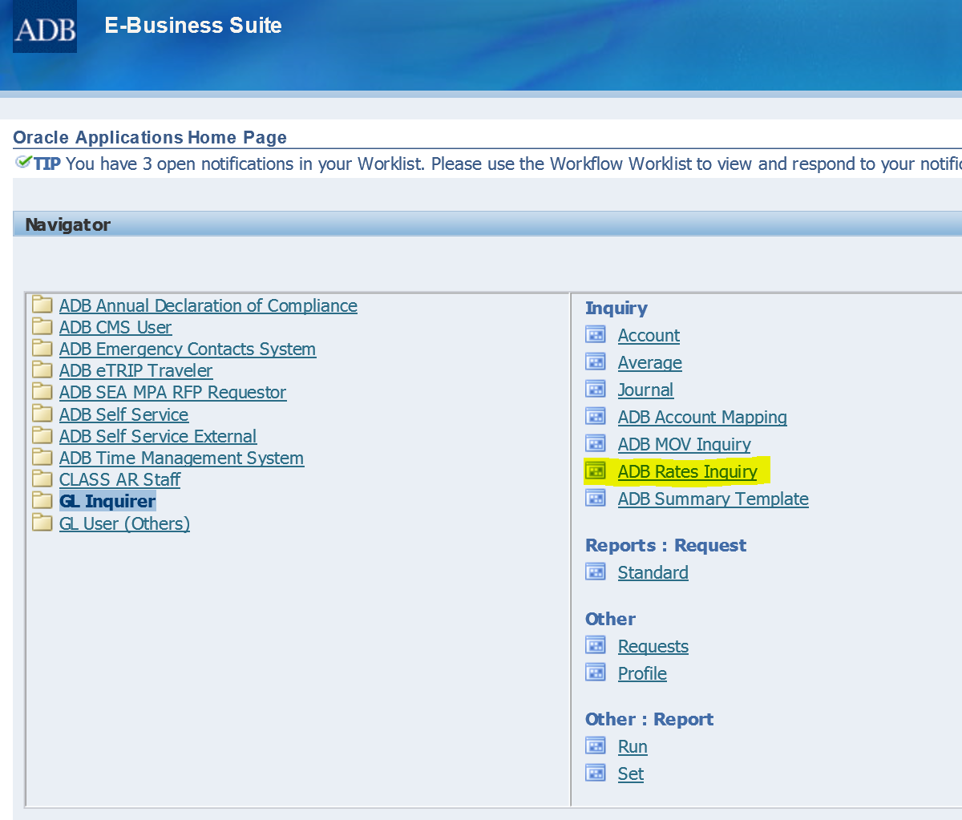

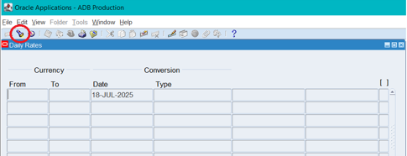

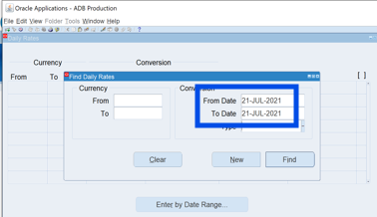

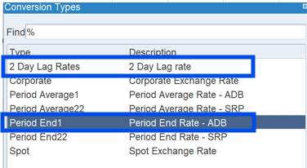

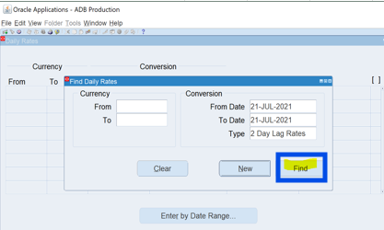

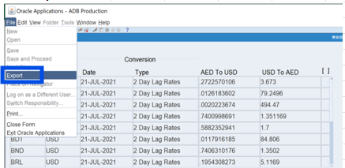

- Compare the foreign exchange rates in the interface file versus the rates downloaded from Oracle.
- DFX_RATE will be compared versus the Period-end rates in Oracle
Interface File Oracle
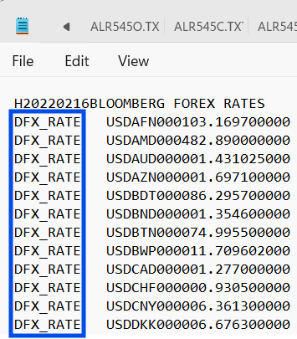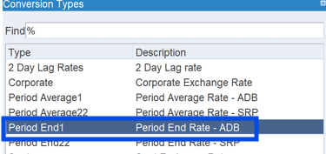

- DBOOK_RATE will be compared versus the 2 Day Lag Rates in Oracle
Interface File Oracle

